Title of the abstract (Times New Roman 12 Bold, “Title” style)
Antonia Firstauthor¹, Bjorn Secondauthor², Carmen Thirdauthor^{2,*} (Times New Roman 10, “Authors” style)
¹ Department of Chemical Engineering, South-East University, City, Country
² Department of Chemical and Biological Engineering, University of Anywhere, City, Country (Times New Roman 10 Italic, “Affiliation” style)
*Corresponding author(s): a.firstauthor@seu.de (A. Firstauthor); b.secondauthor@uoa.de (B. Secondauthor) (Times New Roman 10, “Corresponding” style)

Summary (Times New Roman 10 Bold, “Heading 1” style)
These instructions guide the formatting of long abstracts published in the Proceedings of the 16th International Conference on Gas-liquid and Gas-Liquid-Solid Reactor Engineering (GLS-16). The long abstracts have a maximum total of six pages, which includes all sections identified below. You can change the title of this and other sections to better represent content. Please attempt to address explicitly the conference theme “Multiscale Simulations and Experimental Studies for an Advanced Understanding of Multiphase Reactors” in the Introduction and/or Conclusions of your abstract.
The author names shall be constructed in the format of first-name/given-name, middle-name (if any) followed by the last-name/surname/family-name. The name of the speaker for this submission at the conference shall be underlined. At least one author of each accepted submission shall register for and attend the conference and shall present the work at the conference in accordance with the applicable presentation schedule and style (oral or poster).
Keywords: Please type 3-6 keywords here, separated by commas. Use “Keywords” style (Times New Roman 10).

Introduction (Times New Roman 10 Bold, “Heading 1” style)
The introduction should contain the problem statement and ensuing research objective(s). Use the “Body Text” style (Times New Roman 10) to write the main body of all sections.

Experimental and Numerical Methods
This section should contain your experimental equipment and/or numerical methods. You can also include figures, tables, equations, etc.
Citations: Please cite references following the format requested by Chemical Engineering Science.
https://www.elsevier.com/journals/chemical-engineering-science/0009-2509/guide-for-authors
Citations may be made directly (or parenthetically). Groups of references should be listed first alphabetically, then chronologically. Examples: "as demonstrated (Allan, 1996a, 1996b, 1999; Allan and Jones, 1995). Kramer et al. (2000) have recently shown ...."
Equations should be typed (e.g., using Insert → Equation). Using the Use the “Equations” style (Times New Roman 10) style will allow you to left align the equation and right align the equation number by using tab. All equations should be numbered.
$\left[M\right]\left\{\ddot{x}\left(t\right)\right\}+\left[C\right]\left\{\dot{x}\left(t\right)\right\}+\left[K\right]\left\{x\left(t\right)\right\}=f\left(t\right)$ (1)
$\text{M}\ddot{\text{x}}\left(t\right)+\text{C}\dot{\text{x}}\left(t\right)+\text{Kx}\left(t\right)=f\left(t\right)$ (2)
All tables should be formatted similar to the example shown in Table 1 and referenced in the main body of the paper.
Table 1. Sample Table Title Use the “Caption” style (Times New Roman 10)
Entries | Numbers
Entry 1 | 5
Entry 2 | 17
Entry 3 | 5
Entry 4 | 19
Entry 5 | 21
All figures should have an associated caption and all figures should be referenced in the main body of the paper. Try to use “Cross-reference” when referring to figures and table in the main text. Figure 1 shows a sample figure and caption.
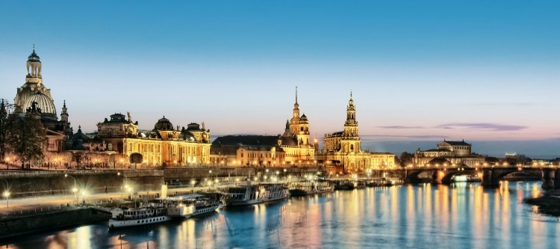
Figure 1: Place here the figure caption. (Use the “Caption” style (Times New Roman 10)

Results and Discussion
This section should present, interpret, and discuss your results. When possible, use tables and figures to present your data. Try to format figure so that they fill the entire width of the column, as shown in Figure 2.
Figure 2: Place here the figure caption. (Use the “Caption” style (Times New Roman 10)
When necessary, use sub-headings to divide sections. Use the “Heading 2” and “Heading 3” styles for secondary and tertiary headings.

Secondary Subsection
Example of a secondary subsection.

Tertiary Subsection
Example of a tertiary subsection.

Conclusions
This section should present main conclusions and recommendations.

Acknowledgments
This section is optional and must be placed before the list of references.

References
Please list references following the format requested by Chemical Engineering Science.
https://www.elsevier.com/journals/chemical-engineering-science/0009-2509/guide-for-authors
Reference to a journal publication:
Zhang, J.-P., Grace, J.R., Epstein, N., Lim, K.S., 1997. Flow regime identification in gas-liquid flow and three-phase fluidized beds. Chem. Eng. Sci. 52, 3979-3992.
Reference to a book:
Fan, L.-S., 1989. Gas-Liquid-Solid Fluidization Engineering, Butterworths, Boston.
Reference to a chapter in an edited book:
Buwa, V.V., Roy, S., Ranade, V.V., 2016. Three-phase slurry reactors, in: Önsan, Z.S., Avci A.K. (Eds.), Multiphase Catalytic Reactors - Theory, Design, Manufacturing, and Applications. John Wiley & Sons Inc., Hoboken, pp. 132-155.

